

**HILLSIDE PRIMARY SCHOOL-NAALYA**

**MID TERM III EXAMINATION 2022**

**INTEGRATED SCIENCE**

***Time Allowed: 2 Hours 15 Minutes***

NAME …………………………………………STREAM ………..……

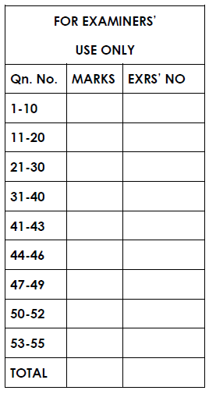**Read the following instructions carefully:**

1. The paper has **two** sections: **A** and **B**.
2. Answer **all** questions. All answers to both section

**A** and **B** must be written in the spaces provided.

1. **All** answers must be written using a blue or black

ball-point pen or fountain pen.

1. Unnecessary changes of work may lead to loss of

marks.

1. Any handwriting that cannot easily be read may

lead to loss of marks.

1. Do **not** fill anything in boxes.
2. Indicated **“For examiners’ Use only**” and those

inside the paper.

**SECTION A: 40 MARKS**

***(Questions 1 to 40 carry one mark each)***

1. Name the breathing organ of a fish.

……………………………………………………………………..……………

2. Mention the disease caused by a lack of enough proteins in the body.

……………….……………………………………….......................................

3. Identify one animal product used in leather industry

………….………………………………………...............................................

4. State one property of matter

……………………………………………………………………..……………

5. Which stage in the lifecycle of a butterfly is dangerous to crop farmer?

……………………………………………………………………......................

***The diagram below shows part of a flower. Use it to answer questions 6 and 7.***

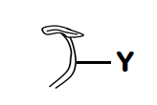

6. What name is given to the part of the flower shown above?

………….………………………………………...............................................

7. Name the part marked with letter **Y**.

………….………………………………………...............................................

8. Mention one component of blood.

……………………………………………………………………..……………

Use the diagram below to answer question 9

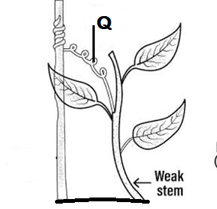

9 Name the structure marked with letter Q

……………………………………………………………………………………

10. Name the of the skeleton that protects the brain.

……………………………………………………………………..……………

12. How is a housefly able to spread germs?

……………………………………………………………………..…………………………….……………………………………….......................................

13. What happens to less dense objects when they are immersed in water?

……………………………………………………………………..……………

14. Give one example of digestive juice in the body.

……………………………………………………………………..……………

15. How do bacteria reproduce?

……………………………………………………………………..……………

16. Why is it not possible for plants to make their own food at night?

……………………………………………………………………..…………………………….……………………………………….......................................

17. Give one way of keeping our toilets clean?

……………………………………………………………………..…………………………….……………………………………….......................................

18. Why are the walls of cinema halls covered with soft boards?

……………………………………………………………………..…………………………….……………………………………….......................................

***The diagram below shows the roots of a plant. Use it to answer question 19.***

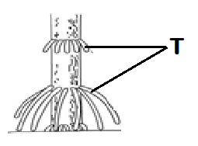

19. State the importance of roots marked T.

……………………………………………………………………..……………

20. Write down one characteristic carnivorous mammals

……………………………………………………………………..……………

....................................................................................................................

21. State any one respiratory disease that is immunisable.

……………………………………………………………………..……………

22. Why do farmers mulch their gardens?

……………………………………………………………………..……………

23. State one traditional method of preserving fish in Uganda.

……….………………………………………..................................................

24. How is pruning important in crop growing?

……………………………………………………………………..…………………………….……………………………………….......................................

25. Why do animals make sound?

……………………………………………………………………..…………………………….……………………………………….......................................

26. How does one become a passive smoker?

……………………………………………………………………..…………………………….……………………………………….......................................

27. Identify the element of PHC promoted by introducing vaccines into the body.

……………….……………………………………….......................................

28. Calculate the volume of the cuboid below.

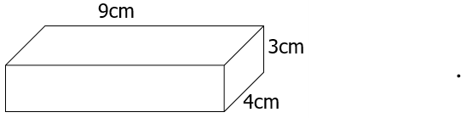

29. State any one cause of soil erosion.

………….………………………………………...............................................

30. How is a banana plant propagated?

……………………………………………………………………..……………

31. How do tapeworms enter our bodies?

……………………………………………………………………..…………………………….……………………………………….....................................

32. How can you control the spread of typhoid at home?

……………………………………………………………………..…………………………….……………………………………….....................................

33. How is the foot of a humming bird adapted to its mode of feeding?

……………………………………………………………………..…………………………….……………………………………….....................................

34. In which one way are moulds harmful to man?

……………………………………………………………………..…………………………….………………………………………......................................

***The diagram below shows a plant’s response to a stimulus. Study it carefully and answer question 35.***

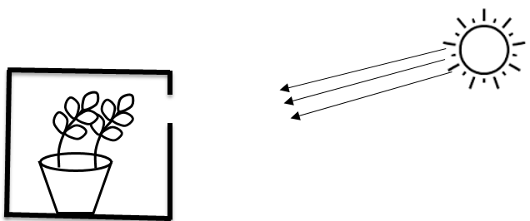

35. Name the type of tropism shown in the diagram above.

……………………………………………………………………..……………

36. Identify any one solvent used in preparation of ORS.

……………………………………………………………………..……………

37. Why is breast milk the best food for babies?

……………………………………………………………………..…………………………….……………………………………….....................................

38. Why do we brush our teeth after every meal?

……………………………………………………………………..…………………………….……………………………………….......................................

39. Identify one way burns can be prevented in our homes.

……………………………………………………………………..…………………………….…………………………………..…….....................................

40. Give the importance of draining stagnant water.

……………………………………………………………………………………………………………………………………………........................................

**SECTION B**

***Questions 41 to 55 carry four marks each.***

41 (a) what do you understand by the following:

1. Heat?

………………………………………………….…………………............…………………….…………..……………………………..................................

(ii) Temperature?

………………………………………………….…………………..…………………………….…………..…………………………….....................................

(b) Give one importance of heat in the environment

.............………………………..……………….…………..……….................

c) How does heat travel through liquids?

....................................................................................................................

42. Give one reason for practising each of the following habits:

(a) Cutting our fingernails short.

……………………………………………………………………..…………………………….……………………………………….......................................

(b) Ironing our clothes regularly

………………..…………………………………………………..…………………………….………………………………………...........................................

(c) Performing physical exercises

……………………………………………………………………..……………..……………….……………………………………….......................................

(d) Sweeping rubbish in the classroom

……………………………………………………………………..…………………………….……………………………………….......................................

43. (a) Name two physical processes involved rain cycle.

(i) ………………………………………………………………....................

(ii) ………………………………………………………………....................

(b) State any one human activity that can lead to drought in an area.

………………………………………………………………………..………………………….…………………………………………...................................

(c) How is the sun useful during rain formation?

……………………………………………………………………..…………………………….……………………………………….......................................

**44. *Study the diagrams below and use them to answer the questions that follow.***

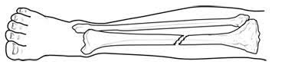

1. Name the type of fracture.

……………………………………………………………………......................

1. What first aid can be given to a person with the above type of fracture?

……………………………………………………………………......................

(c) Mention two other common accidents which occur at school.

i……………………………………………………………………......................

ii…………………………………………………………………….....................

**45. *Match the vectors in list A with the diseases they spread in list B.***

|  |  |
| --- | --- |
| 1. **VECTORS** | 1. **DISEASES** |
| Tsetse fly  Culex mosquito  Housefly  Rat fleas | Bubonic plague  cholera  Nagana  elephantiasis  scabies |

**CORRECT ORDER**

1. Tsetse fly …………………………………...........................................
2. Culex mosquito ………………………………….................................
3. Housefly …………………………………...........................................
4. Rat fleas …………………………………...........................................

46. (a) Name the process that enables the body to generate energy.

………………………………………………………………...........................

(b) Where in the lungs does gaseous exchange occur?

……………………………………………………………………..……………

..................................................................................................................

1. Mention one product of respiration?

……………………………………………………………………..……………

d) Which gas is used in respiration?

……………………………………………………………………..……………

47. (a) What is wind?

……………………………………………………………………..…………………………….……………………………………….......................................

(b) Give **two** uses of wind in the environment.

(i)……………………………………………………………….....................

(ii)……………………………………………………………….....................

(c) Which component of air is used on patients in hospitals?

……………….………………………………………...................................

.............................................................................................................

***48. The diagram below is of a mushroom. Use it to answer questions that follow.***

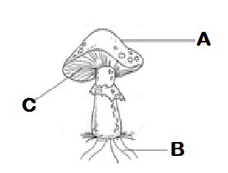

(a) Name parts marked **A** and **B**.

(i) **A** …………………………………………………………….....................

(ii) **C**…………………………………………………………….....................

(b) How useful is part labeled **B** to a mushroom?

……………………………………………………………………......................

……………………………………………………………………......................

(c) To which group of living organisms does a mushroom belong?

……………………………………………………………………......................

49. (a) what name is given a place where seedlings are raised”?

……………….……………………………………….......................................

(b) Mention two crops raised in such a place named above.

i)………………………………………………................................................

ii)……………………..................................................................................

(c) Mention one activity done to care for seedling mentioned above

.……………………………………………………………………..…………….

50. (a) what is **amplitude** as used in sound?

……………………………………………………………………..…………….. ……………….……………………………………….......................................

(b) Mention **two** factors that determine pitch of a musical instrument.

i)……………………………………………………………….........................

ii) ……………………….…………………………………….........................

(c) Mention **one** way of storing sound?

………..…………………………….………………………………...................

....................................................................................................................

51. (a) Name the small stones that are found in the gizzard of a bird.

……………………………………………………………………..…………………………….……………………………………….......................................

(b) State what happens to food in the crop of a bird.

……………………………………………………………………..…………………………….……………………………………….......................................

(c) Apart from using their beaks, how else do birds protect themselves?

……………………………………………………………………..……………..

(d) Give one example of flightless bird

……………………………………………………………………..……………..

52. (a) What are water-borne diseases?

……………………………………………………………………..…………………………….……………………………………… ....................................

(b) Name any two water-borne diseases.

(i) ………………………………………………………………....................

(ii) ………………………………………………………………....................

(c) Suggest any one way of controlling water-borne diseases.

……………………………………………………………………..……………

**53. *The diagram below shows an experiment done by a P.5 class. Study it and answer the questions that follow.***

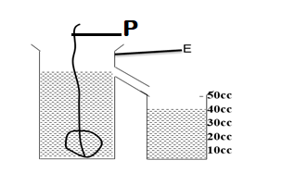

(a) Name the container marked with letter **E**.

……………………………………………………………………..…………….

(b) What was the experiment about?

…….………………………………………………………………....................

(c) State the volume of the stone in the experiment above.

……………………………………………………………………..……………

(d) Give the importance of part P in the above experiment.

……………………………………………………………………..…………………………….……………………………………….....................................

54 (a) Name one breed of sheep that is good for wool production.

……………………………………………………………………..……………

(b) Apart from wool, give one other product got from a sheep.

……………………………………………………………………..……………

(c) Give any **one** reason why docking in sheep rearing should be carried out.

……………………………………………………………………..…………………………….………………………………………....................................

(c) Give one advantage of keeping records on a farm.

……………………………………………………………………..…………………………….………………………………………....................................

**55. *The diagrams below show two different kinds of eggs. Use them to answer questions that follow.***

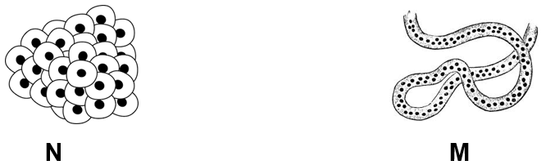

(a) Name the animal that lays eggs shown by letter:

(i) **N** ………………….…………...……………………..………...................

(ii) **M** …………………………………….………………………....................

(b) State any one difference between the two animals named above.

……………………………………………………………………..…………

………….…………………………………………………………..…………

c) What type of fertilization do the eggs above undergo?

........................................................................................................................................................................................................................................